DOCTOR APPOINTMENT SYSTEM

*GEETHIKA S*

**1. INTRODUCTION**

The Console-Based Online Doctor Appointment System is a simple yet efficient Java application designed to facilitate the process of booking appointments with doctors. Patients can use this system to browse the list of available doctors, pick a doctor of their choice, and schedule an appointment for a particular day and time. To ensure smooth interaction between users and the system, it makes use of a MySQL database to hold doctor and patient data.

**2. TECHNOLOGIES USED**

* **Java**: The core programming language used for building the application logic and user interface.
* **MySQL**: The database management system employed to store and retrieve doctor and patient information.

**3. SYSTEM DESIGN**

* **User Interface**: The console interface provides a simple menu-driven design for intuitive user interaction.
* **Database**: The MySQL database schema includes tables for doctors, patients, and appointments.

**4. DATABASE SCHEMA**

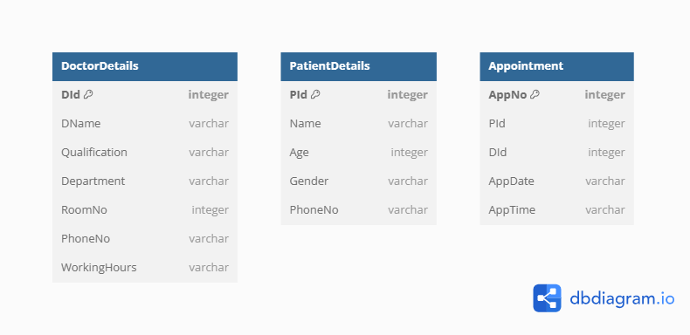

**5. CODE AND OUTPUT SNIPPETS**

* Main Menu

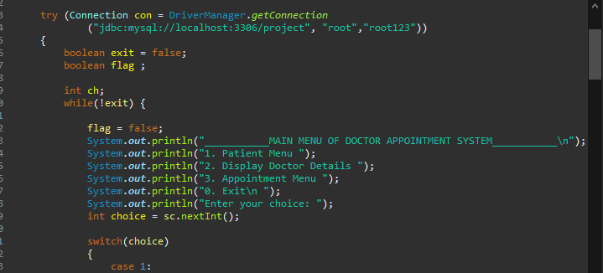

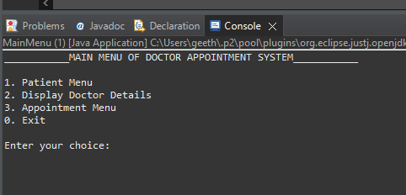

* Patient Menu

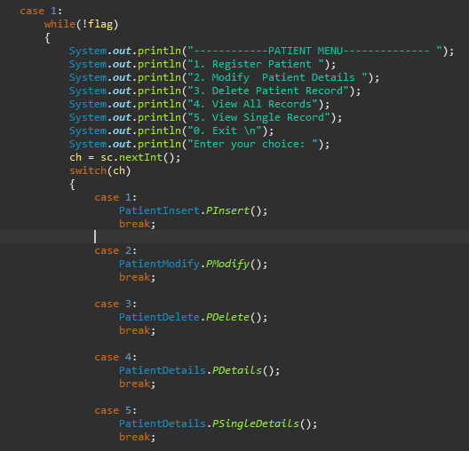

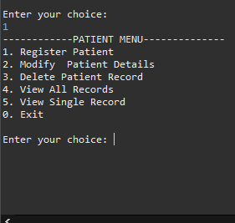

* Doctor details

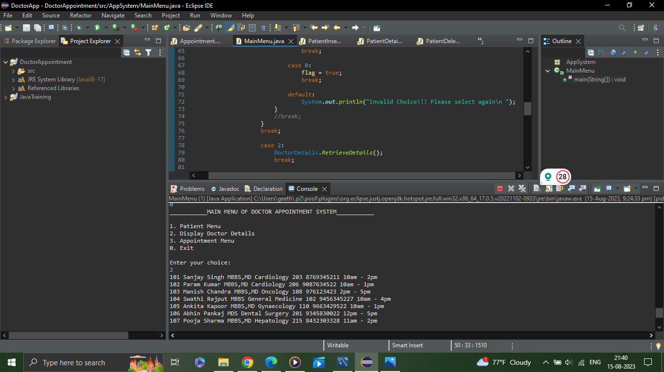

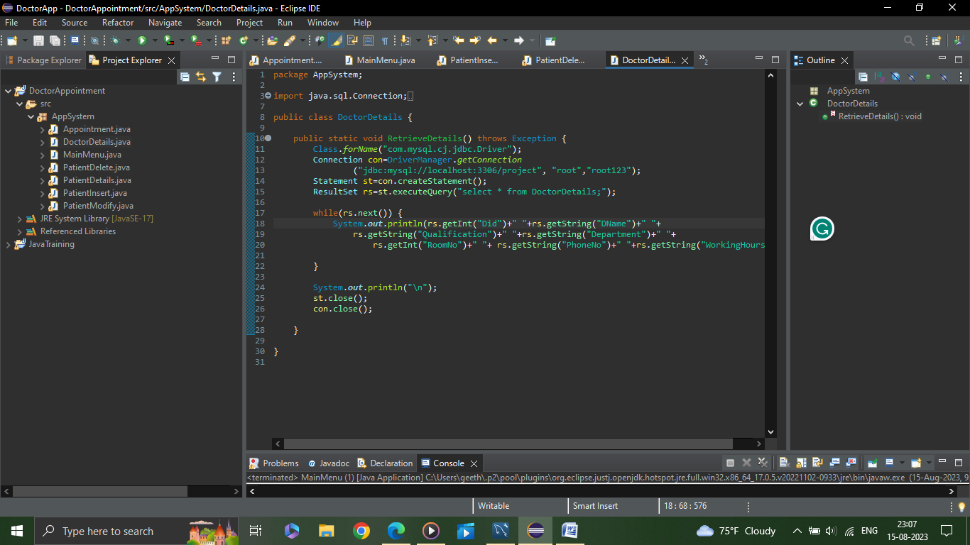

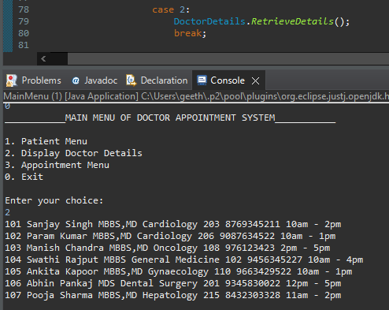

* Appointment Menu

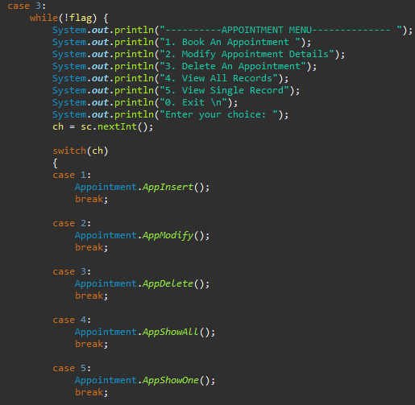

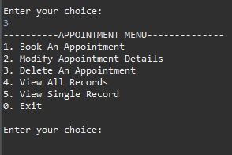

* Register a new patient

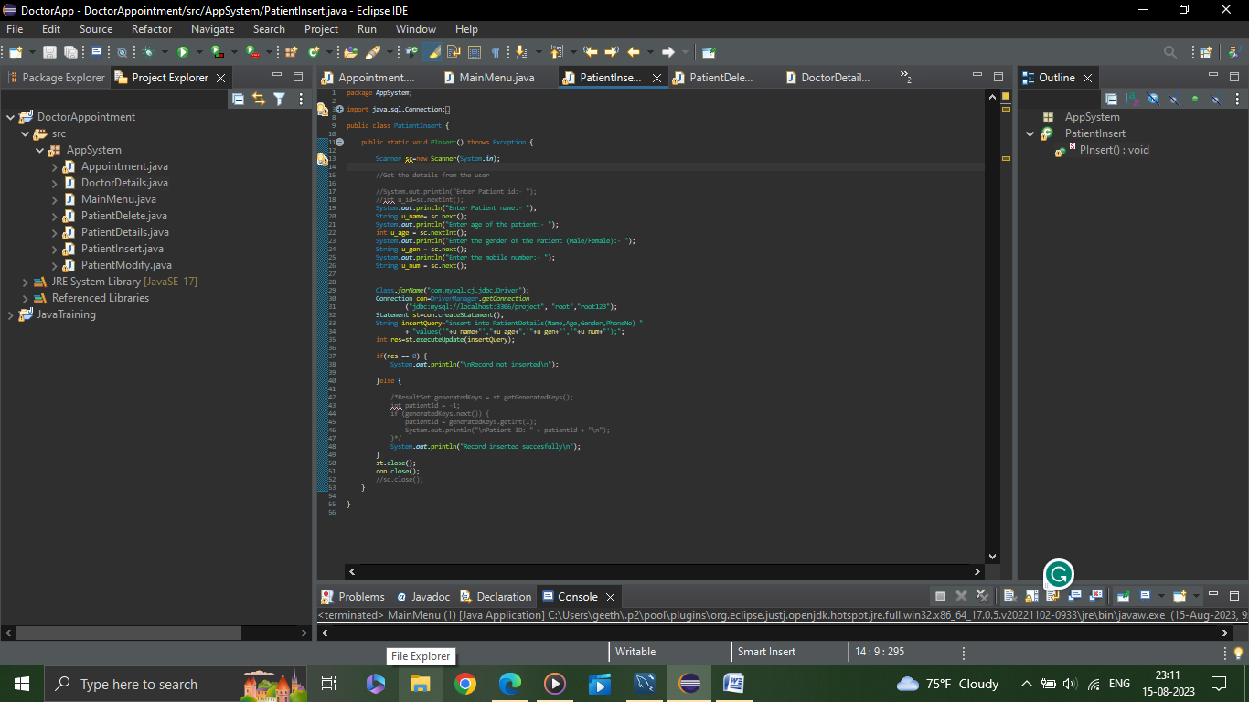

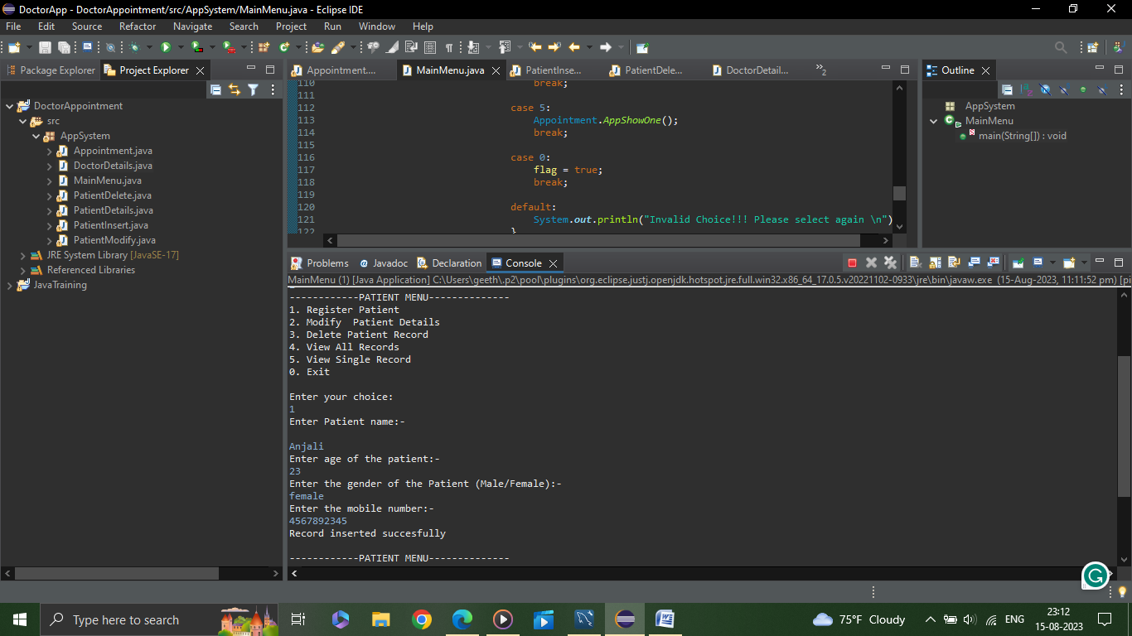

* Modify Patient Details

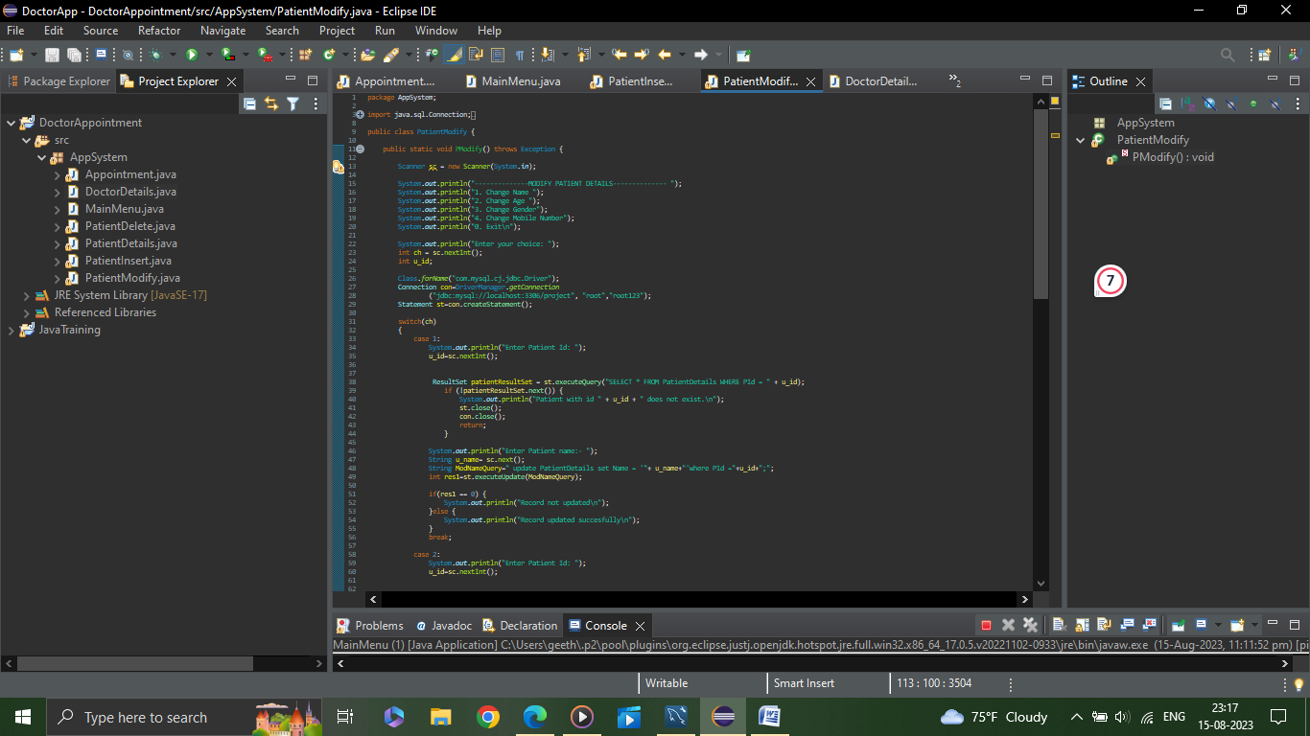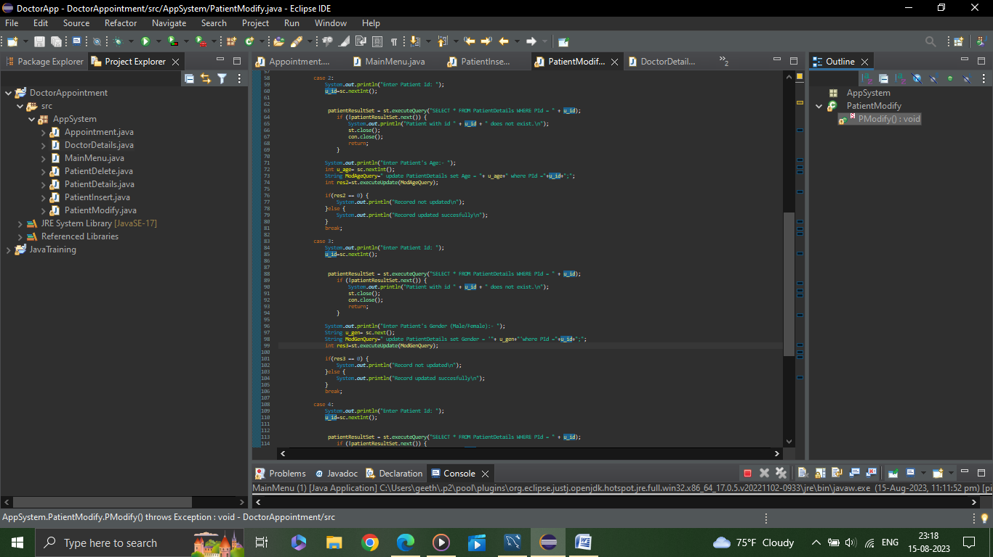

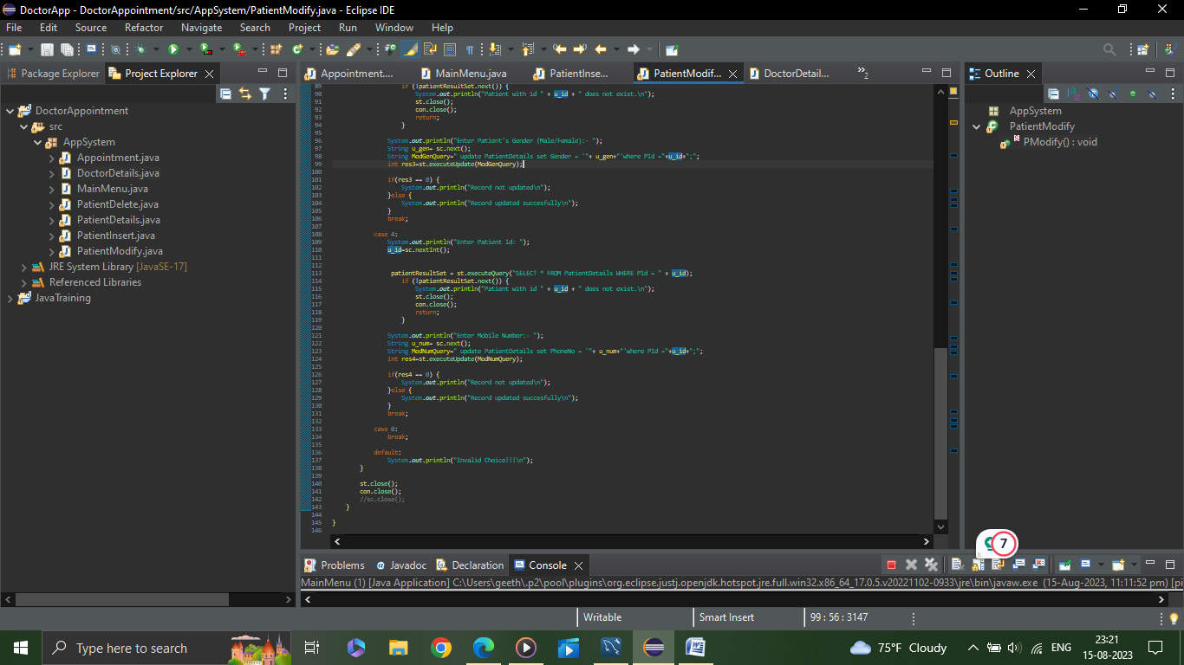

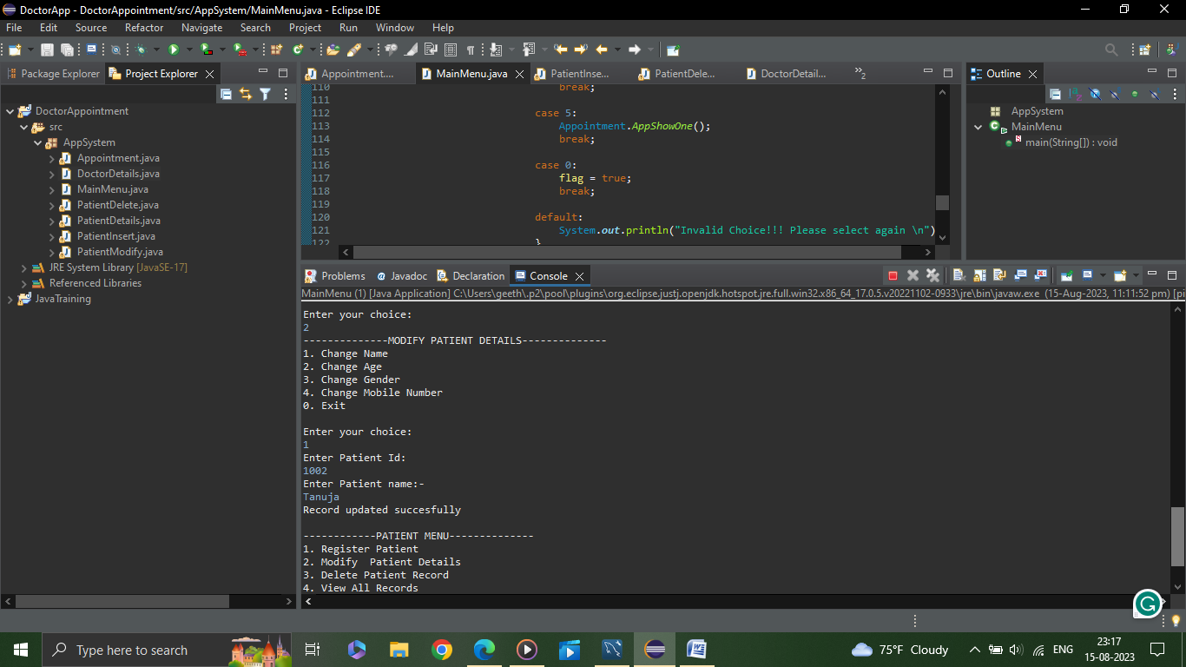

* Delete Patient

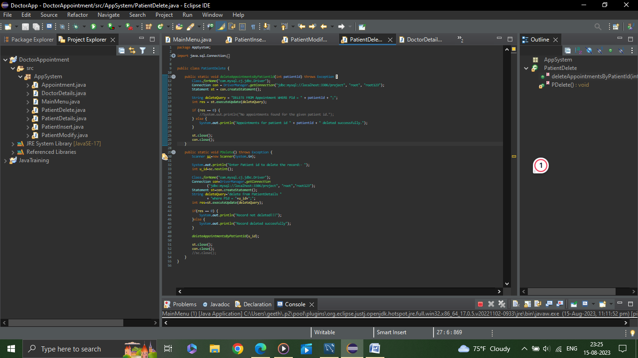

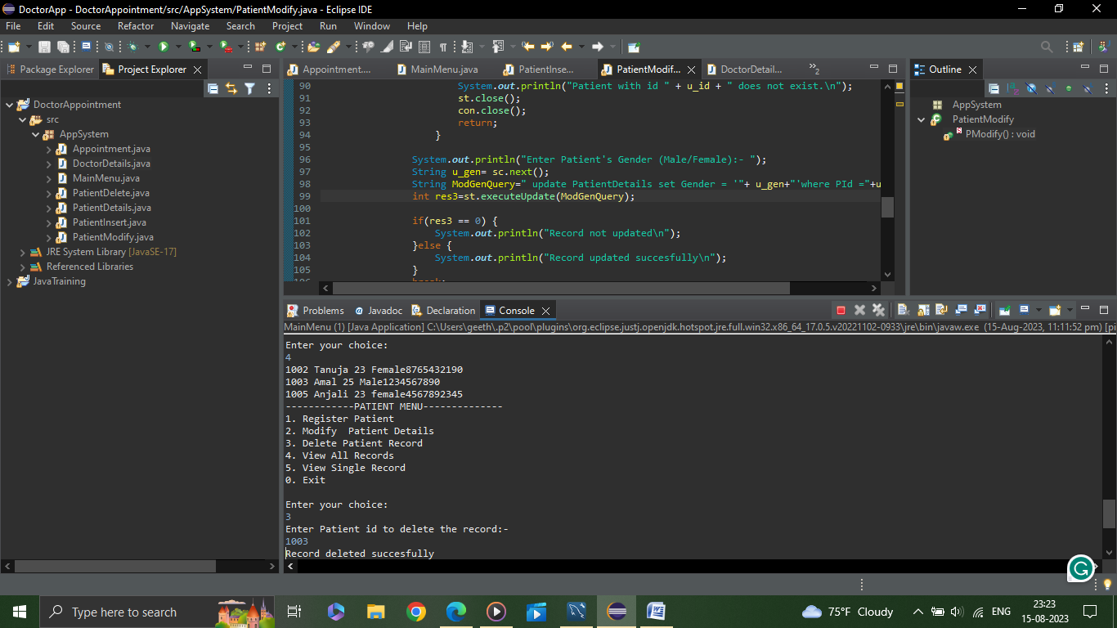

* View all patient records

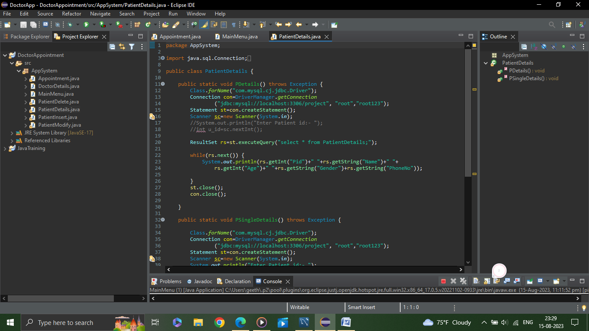

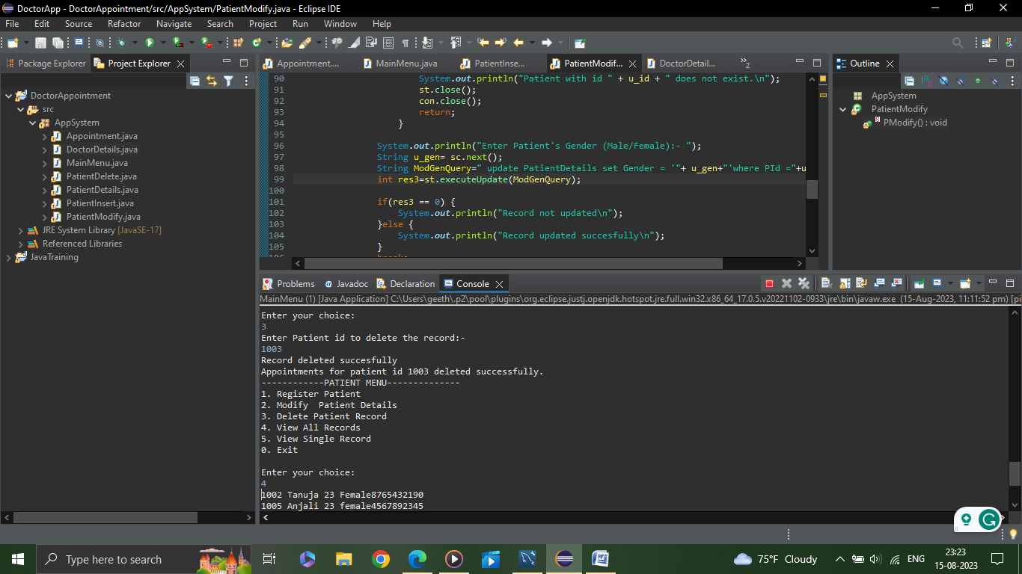

* Display details of a single patient

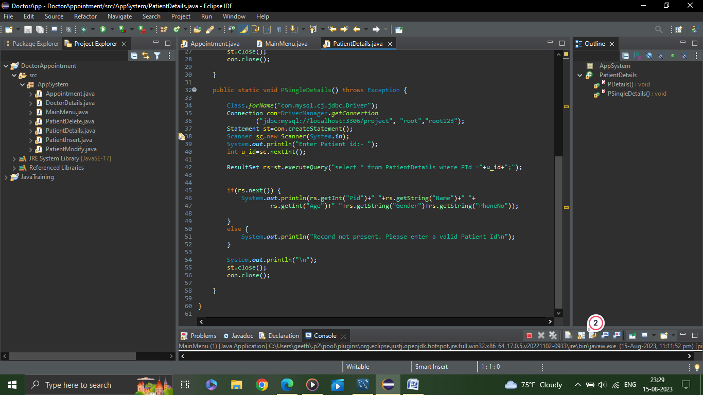

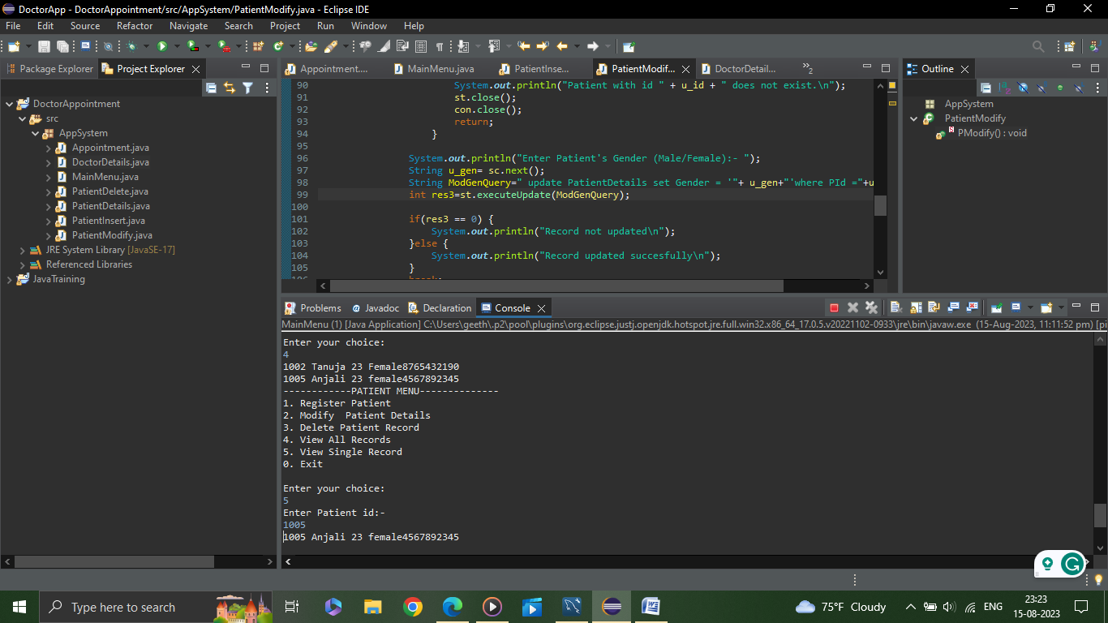

* Book an Appointment

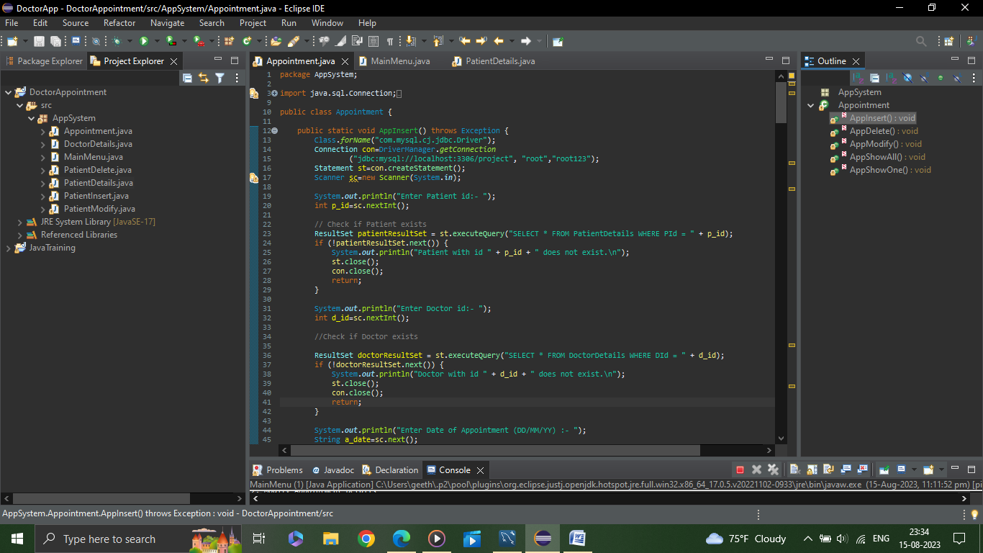

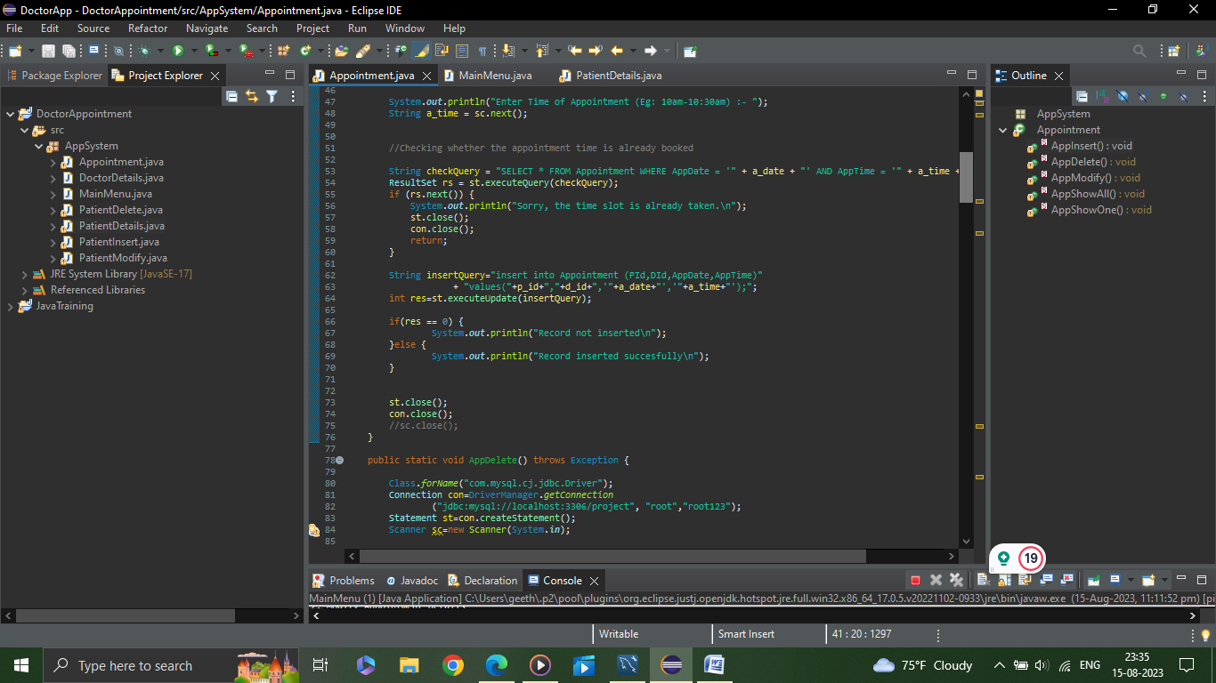

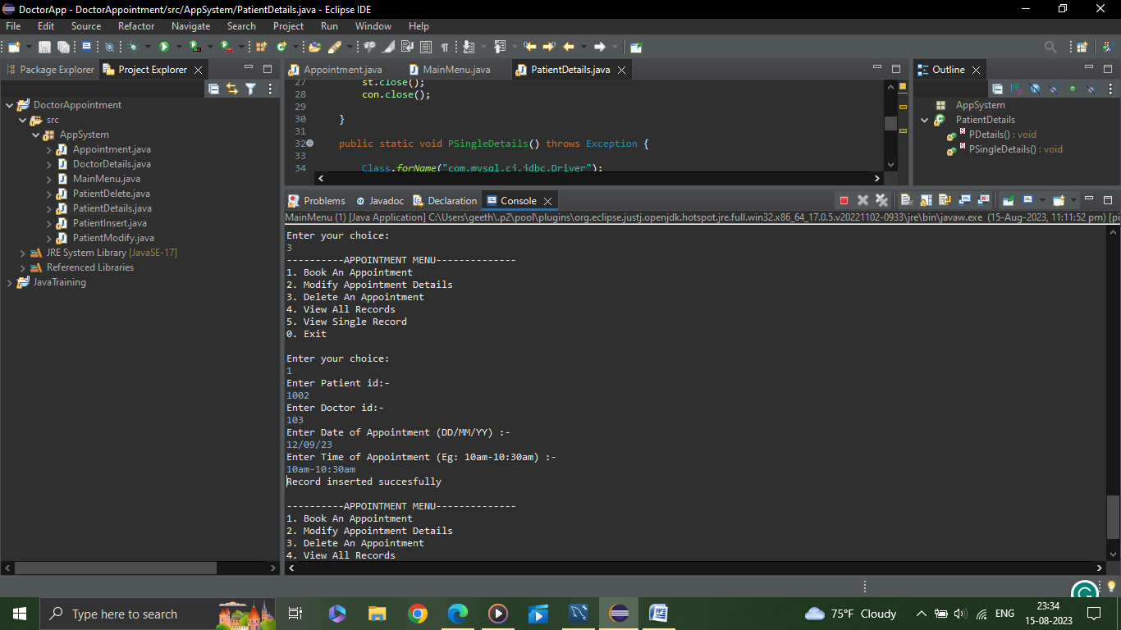

* Modify appointment details

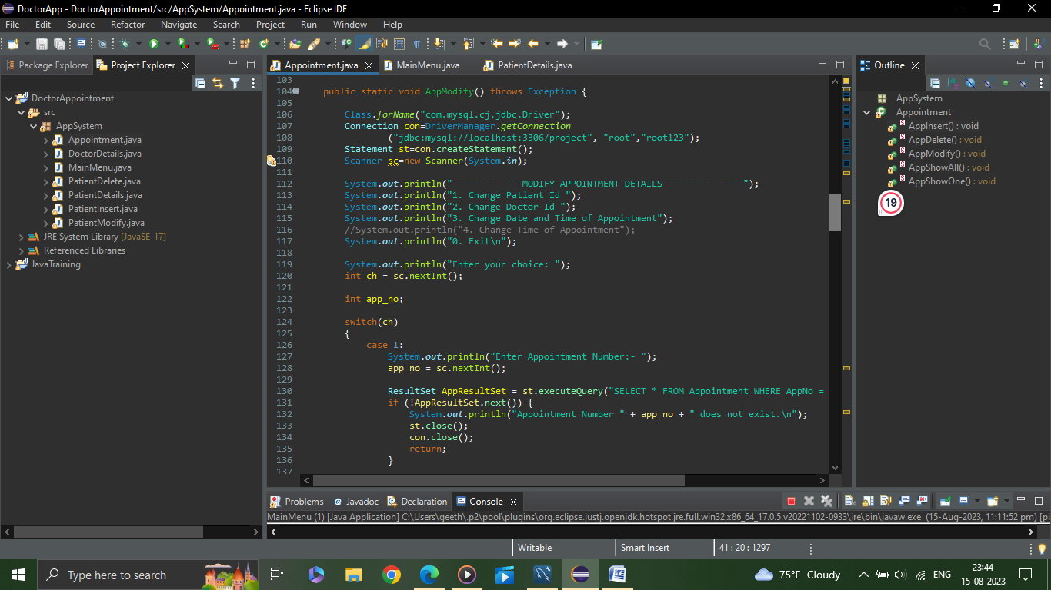 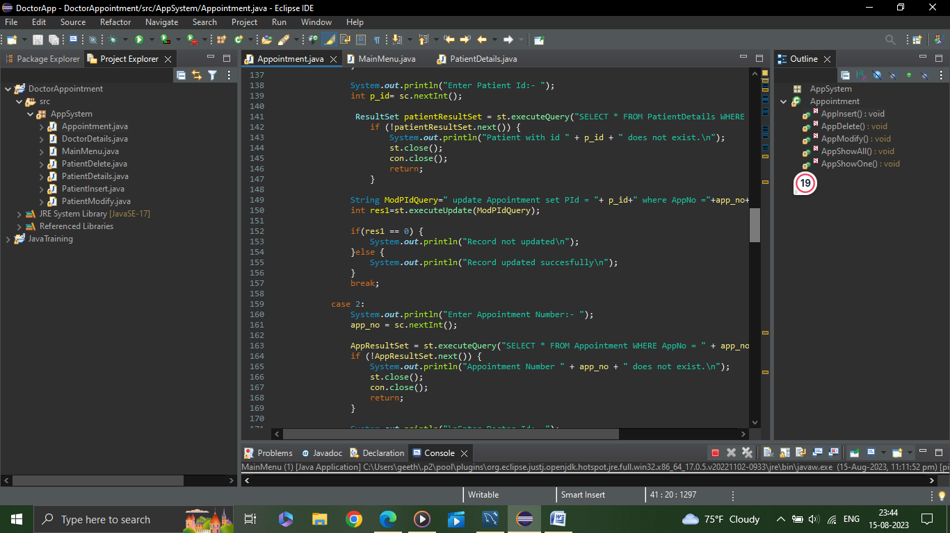

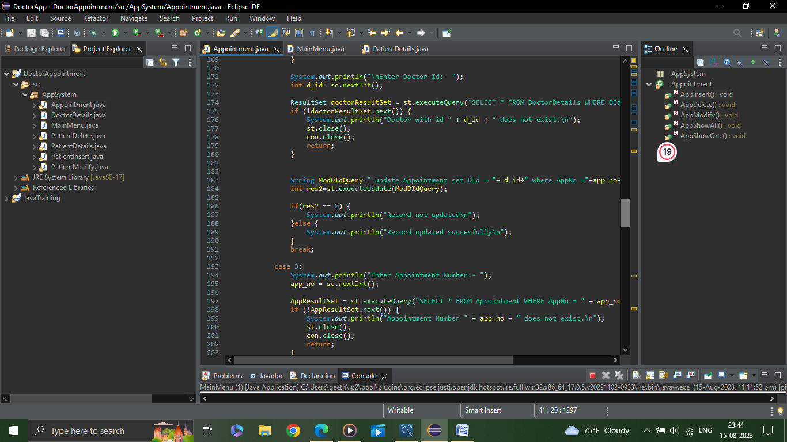 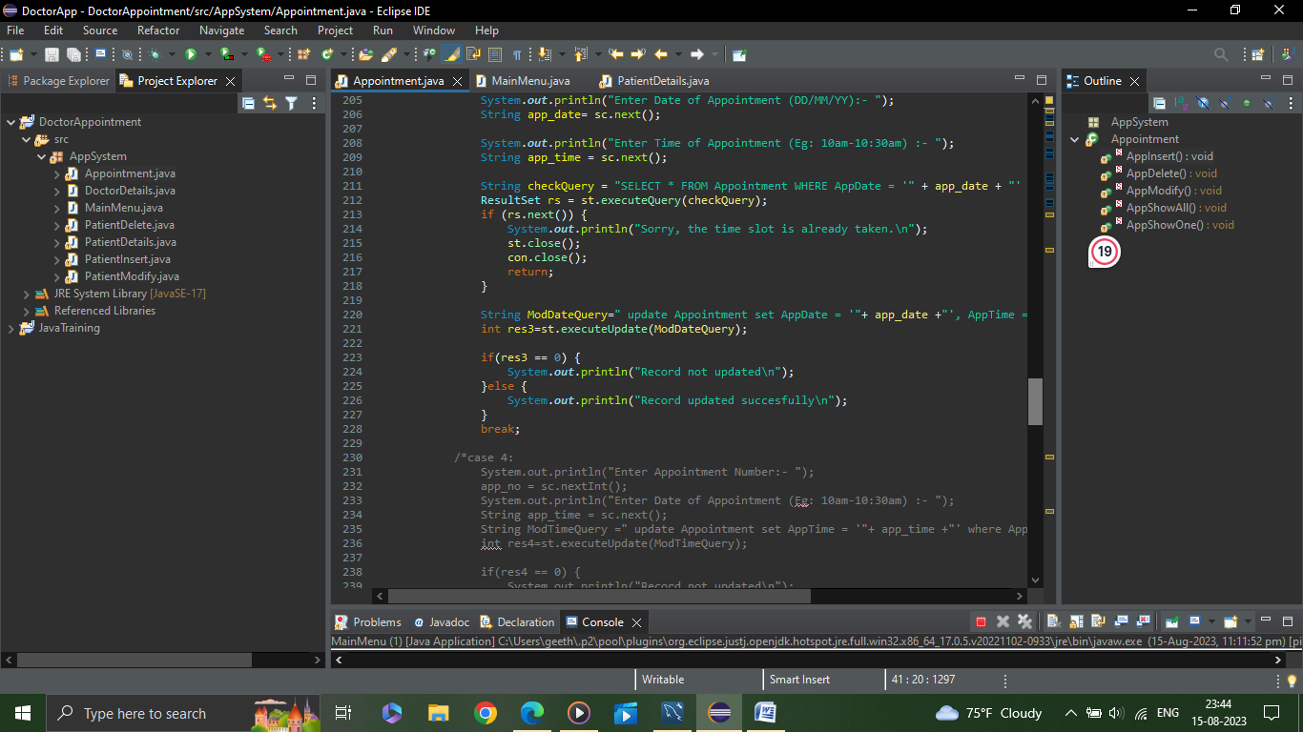

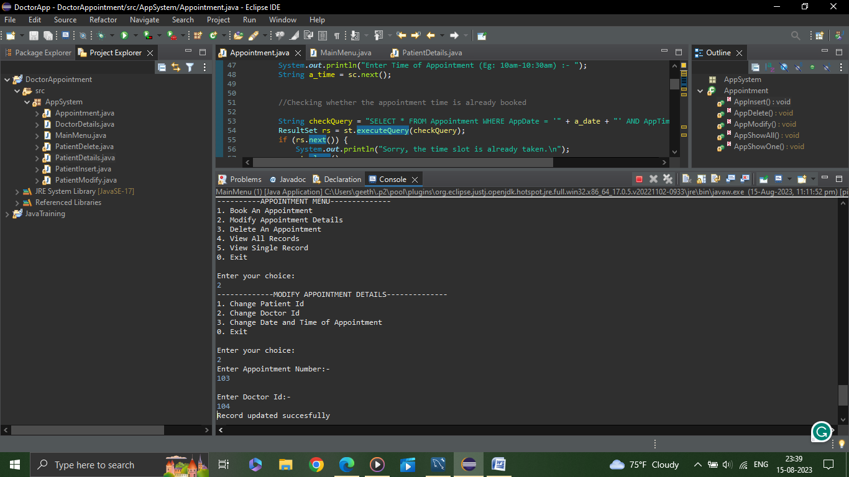

* Delete Appointment

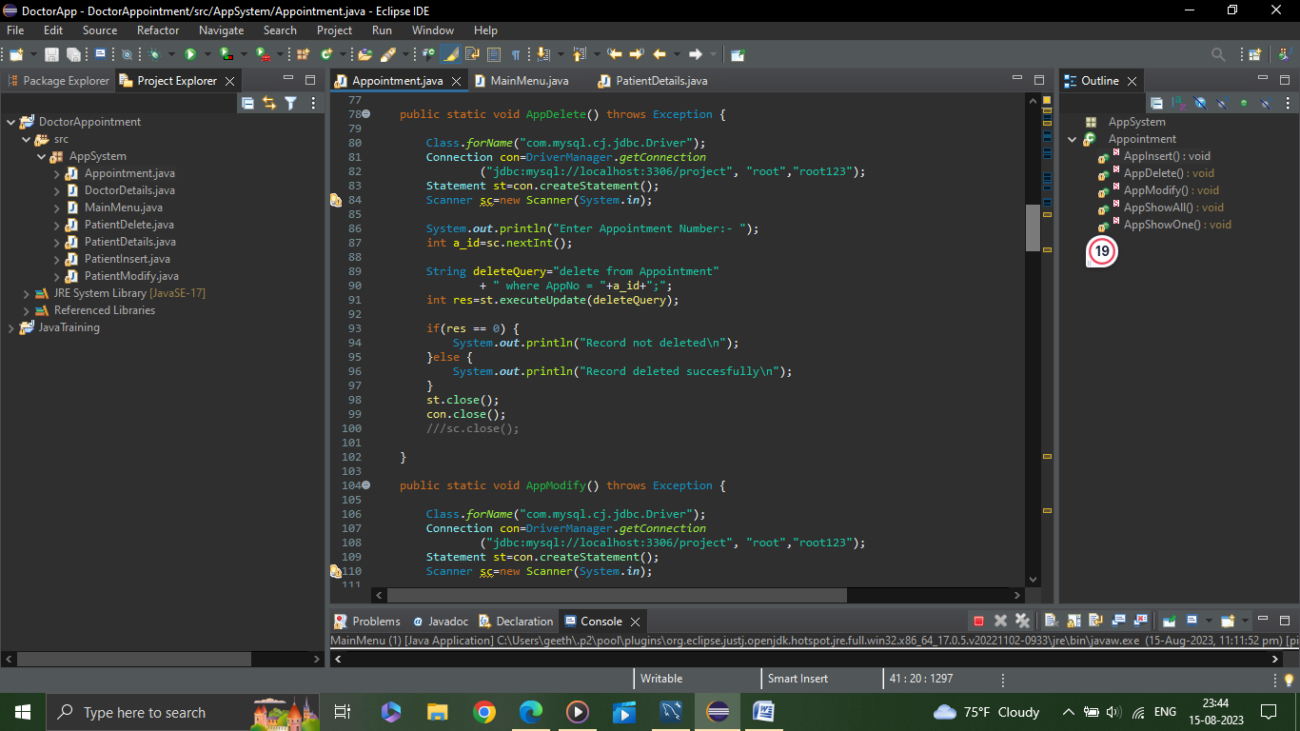

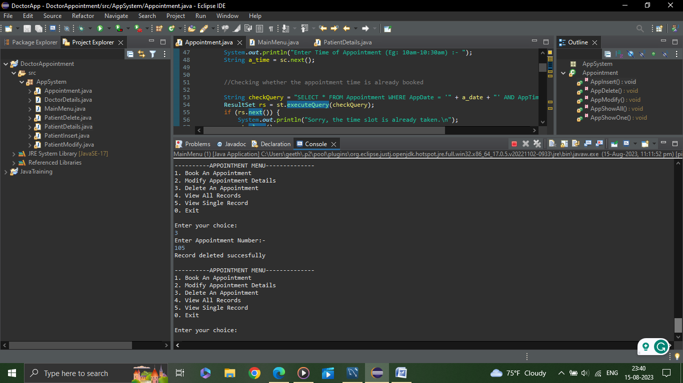

* Display all appointments

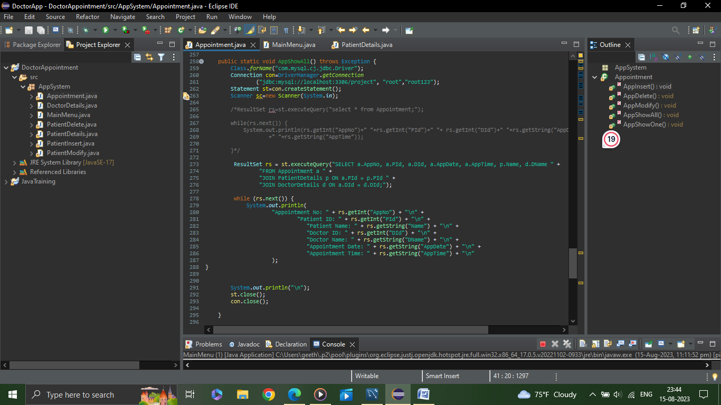

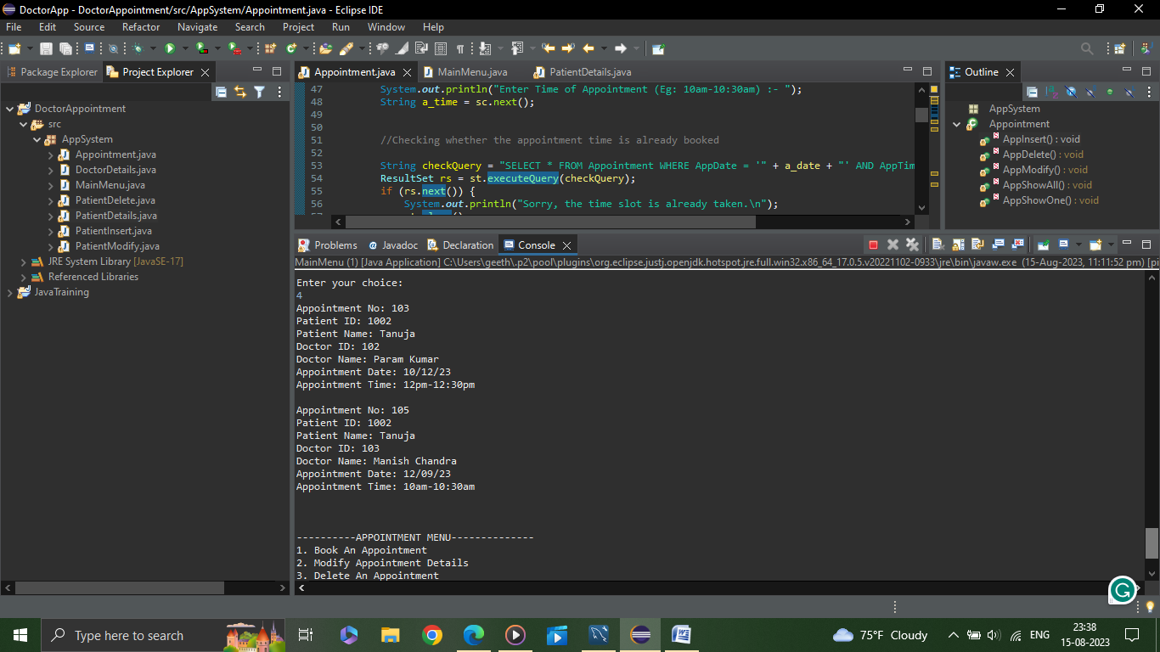

* Display details of an appointment

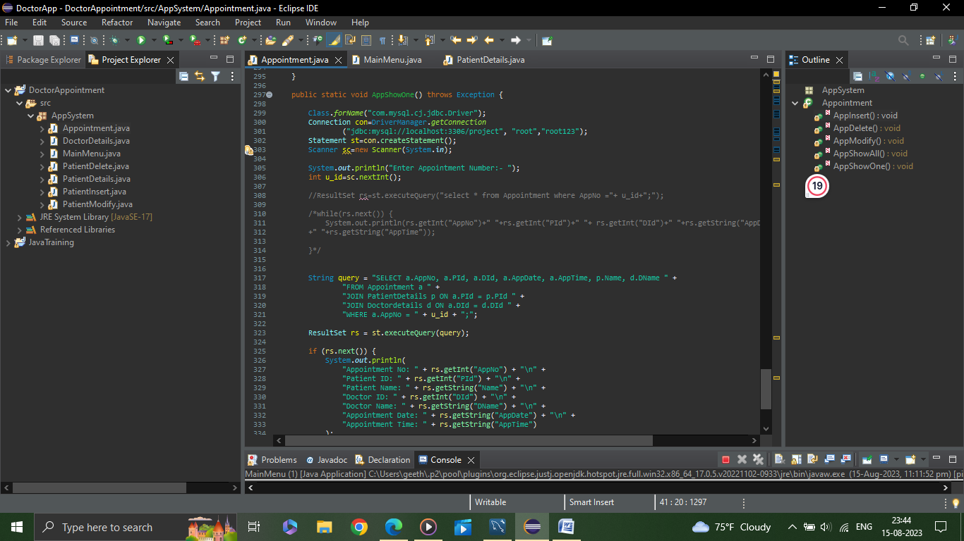

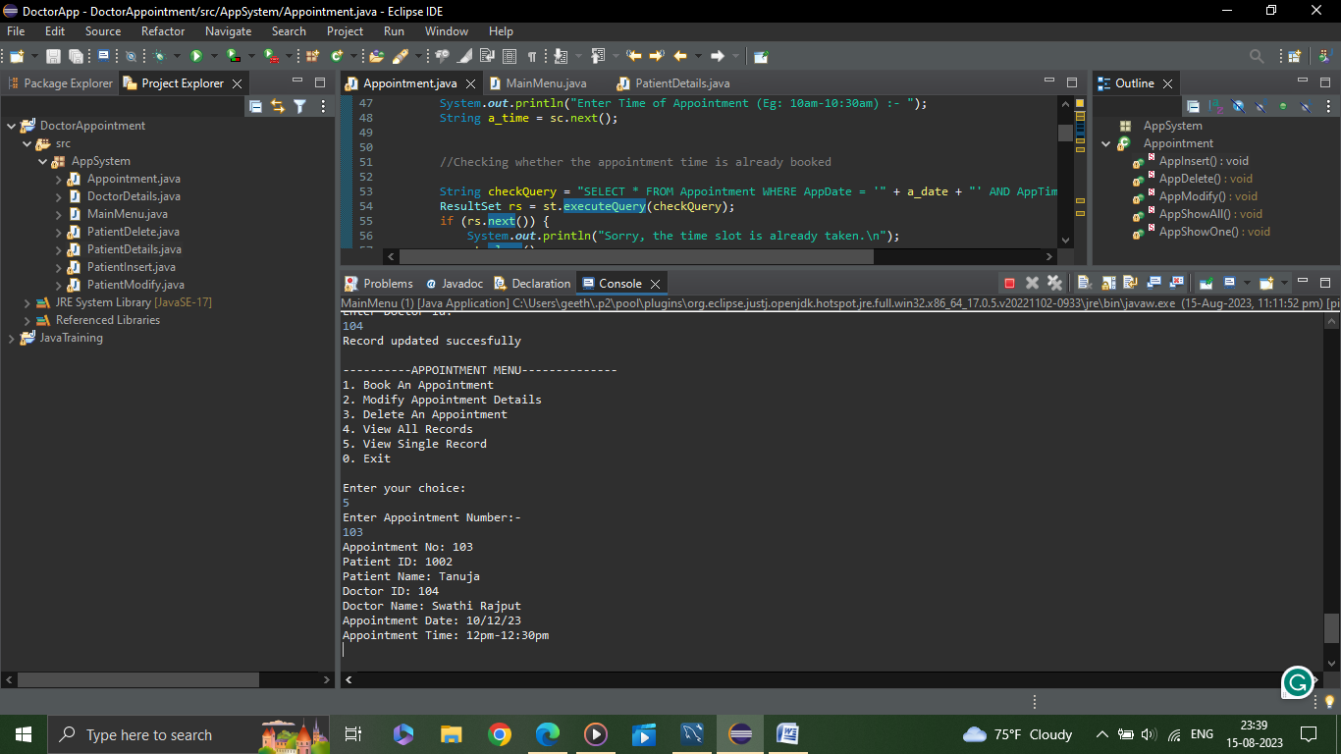

**6. CONCLUSION**

The Online Doctor Appointment System developed using Java and MySQL offers a reliable and efficient platform for patients to manage medical appointments.